**CyberGIS and Big Data (GEOG6282/8282; INES 8090)**

**Title: Lab 1**

**Name: Tamim Adnan**

**Contents**

1. Shell script for creating 500 folders and a text file in each for printing directory

2. output of the shell script.

3. Creating slurm file for submitting the shell script.

4. output of the submitting file

5. some screenshots

**Question -1:**

**1.1 Shell script for creating 500 folders:**

Figure 1. Shell script for creating 500 folders.

To create this script, firstly a shellscript.sh was created using vi command then it was executable using chmod +x shellscript.sh.

* 1. **Output of running this shell script:**

Figure 2. 500 folders by the shell script code

Figure 3. text file in each of the 500 folders having their directory.

**Question 2:**

2.1 **Creating a shell script to submit the job of previous shell script:**

Figure 4: shell script for submitting the file.

To create this submission script, firstly, submit.sh was created using vi command then it was executable using chmod +x submit.sh. then this slurm file was called for running the previous shell script.

2.2 **output of the submitting file:**

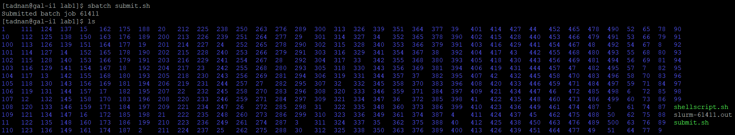

Figure 5. output of the submission file job

3. **Screenshots of working phases:**

Figure 6. codes for the lab1 taken randomly.

**4. Screenshots from WinSCP:**

Figure 7. Screenshots from WinSCP

Figure 8. Screenshots from WinSCP